Problem TPK4140 – Autumn 2009
We shall evaluate the maintenance of a pump system. The pump system comprises two pumps, an active pump (A) and a stand-by pump (B) as shown in Figure 1.

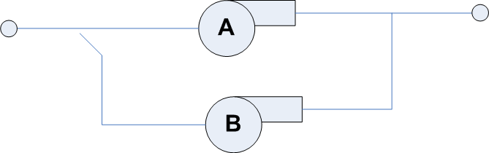
Figure 1 Pump system

If the active pump fails, an attempt is made to start the stand-by pump. There will be a switch-over time before the stand-by pump will be operative. Further the stand-by pump might have failed in stand-by mode. We assume that the active pump has an increasing hazard rate, z(t), whereas the stand-by pump has a constant hazard rate (in stand-by mode). We assume that the stand-by pump will run for a short period of time upon failure of the active pump. In this period we assume that the probability of failure of the stand-by pump equals zero.

Preventive maintenance of the active pump is periodical replacement of wear parts. The maintenance of the stand-by pump is a periodical functional test to reveal any dormant failures in stand-by position. The relevant quantities to consider in the optimization are as follows.

Parameter | Value | Explanation
MTTF_{A} | 6 000 | Mean time to failure for active pump, pump A, in hours (without preventive maintenance)
MTTF_{B} | 10 000 | Mean time to failure for stand-by pump, pump B, in hours. The MTTF_{B} is related to the stand-by mode of operation, we ignore the probability of failure if the stand-by pump is in an operative mode.
α | 3 | Aging parameter for the active pump
C_{PM} | 1 000 | Cost of execution of a PM activity. Same cost for both of the pumps
C_{CM} | 5 000 | Cost of repairing a pump upon failure. Same cost for both pumps
MTT_{O} | 0.2 | Expected switch-over time. I.e., duration of production loss by failure of active pump before stand-by pump is in operation
MDT | 4 | Mean down time in case of stand-by pump will not start. Downtime is assumed to be exponentially distributed
C_{U} | 15 000 | Cost of one hour loss of production
C_{System} | 100 000 | Extra cost if the system is down for more than 6 hours.
τ_{A} | 2 190 | Maintenance interval for active pump, pump A (initial maintenance program)
τ_{B} | 8 760 | Maintenance interval for stand-by pump, pump B (initial maintenance program)

In this problem you may approximate the effective failure rate for the active pump by the following formula:
where Γ(⋅) denotes the gamma function. In this problem you may use the following results:
- Γ(1+1/3) = 0.893
- For a stand-by unit which is periodically tested at intervals of length τ the probability of failure on demand is given by PFD = λτ/2 = τ/(2MTTF)
- In the exponential distribution, Pr(X > x) = e^{-λx}, where λ = 1/E(X).

- Write down an expression for the expected cost per unit time as a function of τ_{A} and τ_{B}
- Assume that we fix τ_{B} = 8 760. Find an analytical expression for the optimal interval for the active pump, τ_{A}. Insert values to find a numerical answer.
- Fix the value for τ_{A} found in problem b), and optimize with respect to τ_{B.}
- Failure data for a similar pump as the active pump has been collected. This pump has been operated on a “Run to failure” basis due to less critical production. Failure times (local time) are 3900, 9900, 6000, 1800, 8100, 8700, 9200, 3100, 3000, 6300, and 4100. All failure times are given in hours. Construct a TTT plot for the data. Compare the plot with the TTT transform given in Figure 2, and make an assessment of the reliability parameters in the Weibull distribution. Comment on the choice of Weibull as a parametric model.
- Give a qualitative argument whether the updated τ_{A} will increase or decrease with the new parameters.
- Propose an RCM decision logic to determine type of maintenance. Apply this logic in order to determine type of maintenance for the pump system. Comment the result according to the type of maintenance assumed in this problem. NB: Was not included in the exam paper

Figure 2 – TTT transform with α = 3 in the Weibull distribution

Solution

a)

C(τ_{A}, τ_{B}) = C_{PM}/τ_{A} + C_{PM}/τ_{B} + λ_{E}(τ_{A})[C_{CM} + C_{U} ⋅MTT₀ + PFD(τ_{B}) (C_{U} ⋅MDT + p⋅C_{System})]

where p = exp(-6/MDT) ≈ 0.223.

Note that corrective maintenance of the passive pump has not been included. The contribution is more or less independent of the test interval τ_{B}
b)

c)

d) TTT-plot shown below. Rather good fit to the Weibull, but α is less than 3

T_{(i)} | ΣT_{(i)} | ΣT_{(i)+}(n-i)T_{(i)} | i/n | TTT | 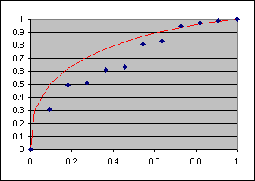
1800 | 1800 | 19800 | 0.09 | 0.31
3000 | 4800 | 31800 | 0.18 | 0.50
3100 | 7900 | 32700 | 0.27 | 0.51
3900 | 11800 | 39100 | 0.36 | 0.61
4100 | 15900 | 40500 | 0.45 | 0.63
6000 | 21900 | 51900 | 0.55 | 0.81
6300 | 28200 | 53400 | 0.64 | 0.83
8100 | 36300 | 60600 | 0.73 | 0.95
8700 | 45000 | 62400 | 0.82 | 0.97
9200 | 54200 | 63400 | 0.91 | 0.99
9900 | 64100 | 64100 | 1.00 | 1.00

e) Since α < 3 as assumed in problem b), the bath tub curve is ”less” sharp, and τ_{A} would then be lower since the risk of “moving towards” the right end of the bath tub curve is then higher, if we assume the same MTTF. Note that an estimate of MTTF is ΣT₍₁₁₎/11 ≈ 5 827 which is very close to the assumption in the problem statement.

f) See course compendium for a decision logic. No observable failure progression, hence move to the “aging parameter α > 1” which is the case for the active pump, hence Overhaul (or Replacement) is appropriate as indicated. For the passive pump, we have aging parameter α =1, hence no we ask for hidden function. For the passive pump the function is hidden, hence functional test seems appropriate. A functional test would be to start the passive pump now and then.

